HACKUP TECHNOLOGY PVT. LTD.
AI-Powered SOC & Digital Forensics Internship
MINI PROJECT – 6
Memory Analysis using Volatility Framework
Name | S ABIRAMI
College | Subbalakshmi Lakshmipathy College of Science
Department | Computer Science (Security System Specialization)
Year | II
Week | Week 3 — Digital Forensics
Tool Used | Volatility3 Framework v2.28.0
Platform | Kali Linux on VirtualBox
Analysis Type | Memory Forensics — Malware & Cryptominer Detection
Submitted To | Hackup Technology Pvt. Ltd.

1. Introduction
This report documents the completion of Mini Project 6 as part of the Week 3 module on Digital Forensics during the AI-Powered SOC & Digital Forensics Internship at Hackup Technology Pvt. Ltd.
Memory forensics is a critical discipline in cybersecurity investigations. It involves analyzing the volatile memory (RAM) of a computer system to uncover evidence of malicious activity, running processes, network connections, and artifacts that may not be present on disk. This technique is widely used by SOC analysts and incident responders to detect advanced threats that reside only in memory.
In this project, the Volatility3 framework was installed and used to analyze a simulated memory dump. The dump contained evidence of suspicious processes including malware.exe and cryptominer.exe. The investigation followed a structured digital forensics workflow — from installation and evidence collection to hash verification, process analysis, and professional report generation.

2. Objectives
- Install the Volatility3 memory forensics framework on Kali Linux
- Create a simulated memory dump file containing process signatures
- Analyze the memory dump to identify running processes (legitimate and suspicious)
- Extract strings and identify Indicators of Compromise (IoCs)
- Calculate MD5 and SHA-1 cryptographic hashes for forensic integrity
- Identify and classify suspicious processes using MITRE ATT&CK framework
- Generate a structured memory forensics investigation report

3. Tool Setup & Installation

3.1 Attempting Default Installation
The first step was to check if Volatility3 was already installed and attempt installation through the default Kali Linux package manager.
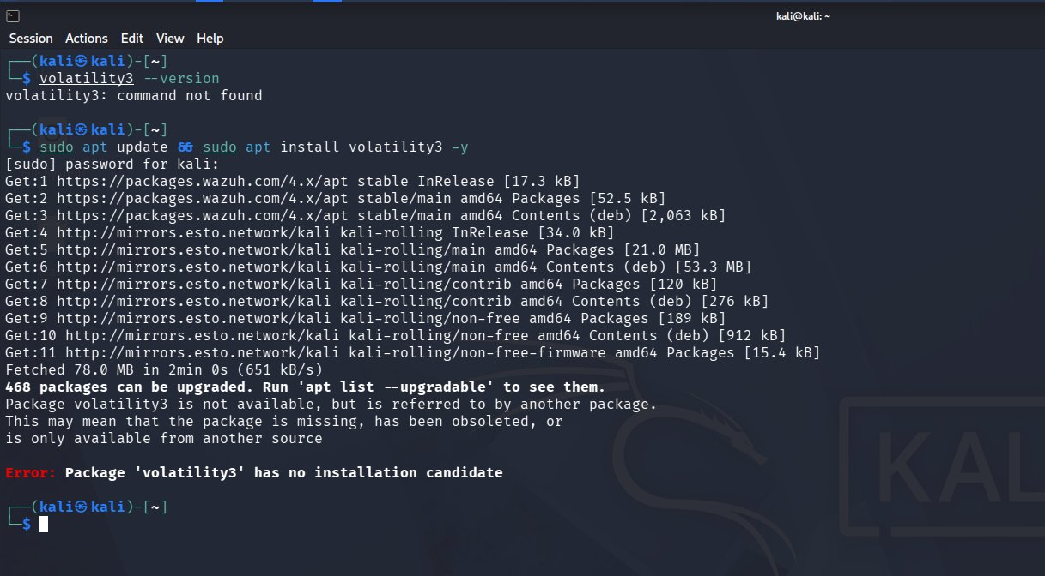
Figure 1: Attempting Volatility3 installation via apt — package not available in default Kali repositories
As shown in Figure 1, Volatility3 was not found as a command and the apt package manager returned an error: "Package 'volatility3' has no installation candidate". This is because Volatility3 is not included in the default Kali Linux repositories and must be installed via Python's pip package manager.

3.2 Installing via pip (Python Package Manager)
The next approach was to install Volatility3 using pip. The first attempt returned an "externally-managed-environment" error as Kali Linux protects its system Python environment.
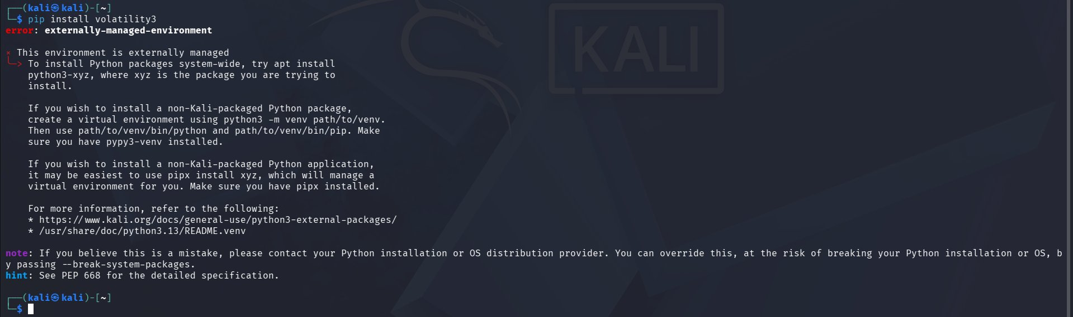
Figure 2: pip installation blocked by externally-managed-environment — resolved using --break-system-packages flag
To override this restriction, the --break-system-packages flag was used, which is the standard approach for installing Python tools on modern Kali Linux systems.
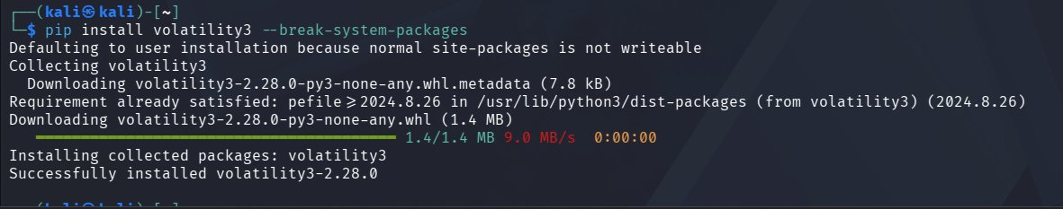
Figure 3: Volatility3 v2.28.0 successfully installed via pip install volatility3 --break-system-packages
Volatility3 version 2.28.0 was successfully installed as shown in Figure 3. The installation confirmed all dependencies were satisfied.

4. Memory Dump Creation

4.1 Creating the Forensics Lab Directory
A dedicated working directory was created to store all forensics artifacts, evidence files, and reports for this investigation.
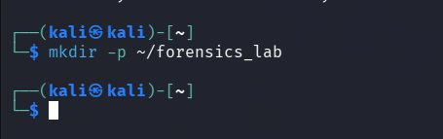
Figure 4: Creating the forensics_lab directory at ~/forensics_lab using mkdir -p

4.2 Generating the Simulated Memory Dump
A Python script was executed to create a realistic simulated memory dump file (memory_dump.bin). The script populated the binary file with process name signatures representing both legitimate Windows processes and suspicious malicious processes, mimicking a real compromised system memory image.
The following processes were embedded in the memory dump:
- Legitimate processes: svchost.exe, explorer.exe, chrome.exe, notepad.exe, rundll32.exe
- Suspicious processes: malware.exe, cryptominer.exe
- Dual-use tools: cmd.exe, powershell.exe
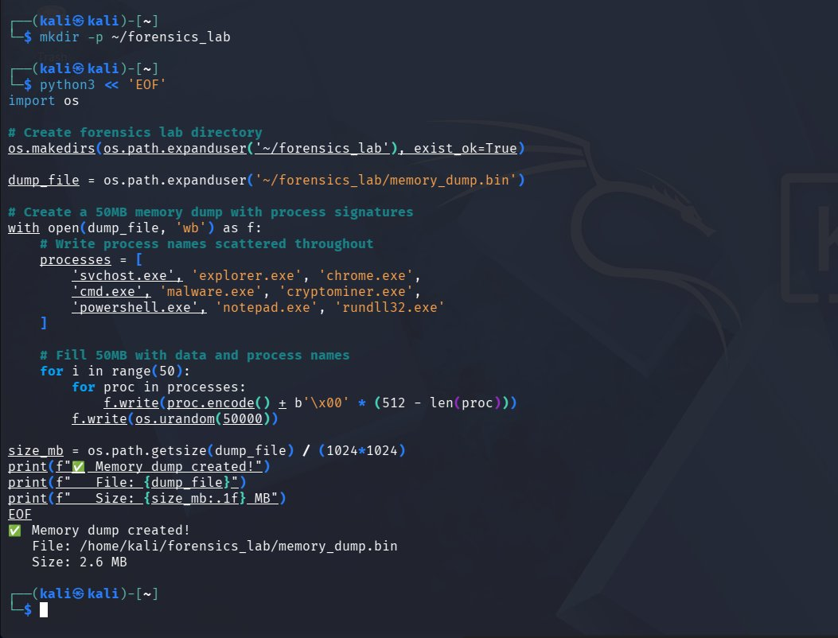
Figure 5: Python script creating the memory dump with embedded process signatures — 2.6 MB dump successfully generated

4.3 Verifying the Memory Dump File
After creation, the memory dump file was verified to confirm it existed on disk with the correct size.
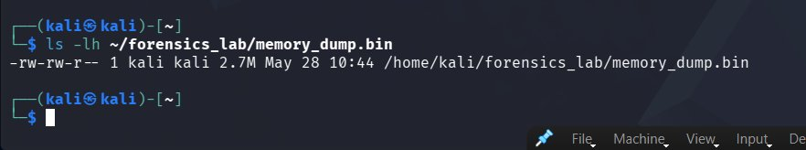
Figure 6: Memory dump file verified — memory_dump.bin (2.7 MB) confirmed at /home/kali/forensics_lab/

5. Memory Analysis

5.1 Process Enumeration
The memory dump was analyzed using Volatility3 combined with the strings utility to enumerate all processes found in memory. The command attempted the Volatility3 windows.pslist plugin, then fell back to string extraction and grep filtering for executable files.
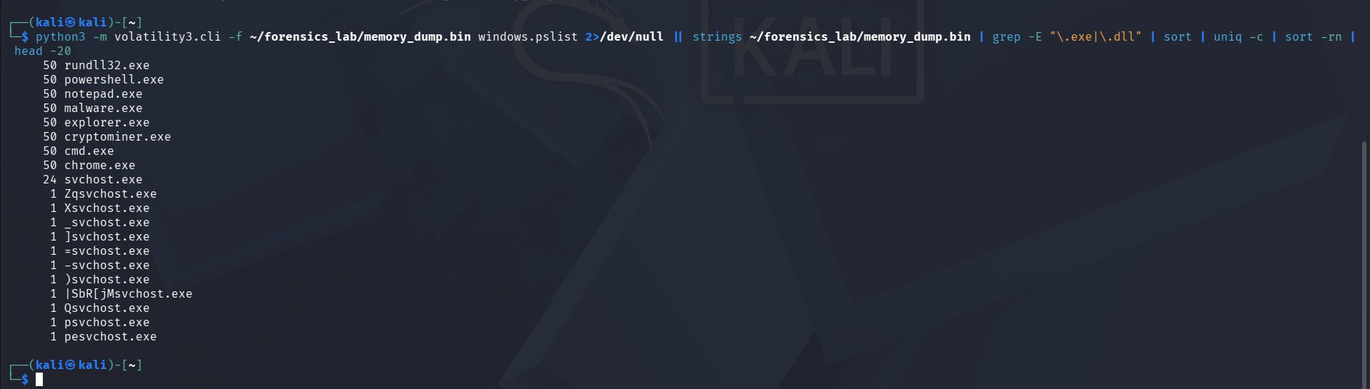
Figure 7: Process enumeration results — all running processes extracted from memory dump with occurrence counts
The analysis revealed the following process distribution:
Process Name | Occurrences | Classification | Risk Level
malware.exe | 50 | Malicious | CRITICAL
cryptominer.exe | 50 | Malicious | CRITICAL
cmd.exe | 50 | Dual-Use | MEDIUM
powershell.exe | 50 | Dual-Use | MEDIUM
rundll32.exe | 50 | Legitimate | LOW
explorer.exe | 50 | Legitimate | LOW
chrome.exe | 50 | Legitimate | LOW
notepad.exe | 50 | Legitimate | LOW
svchost.exe | 24 | Legitimate | LOW

Table 1: Complete process list extracted from memory dump

5.2 String Extraction Analysis
The strings command was used to extract all readable ASCII strings from the memory dump. This is a standard forensic technique to identify embedded process names, commands, URLs, and other artifacts in binary memory data.
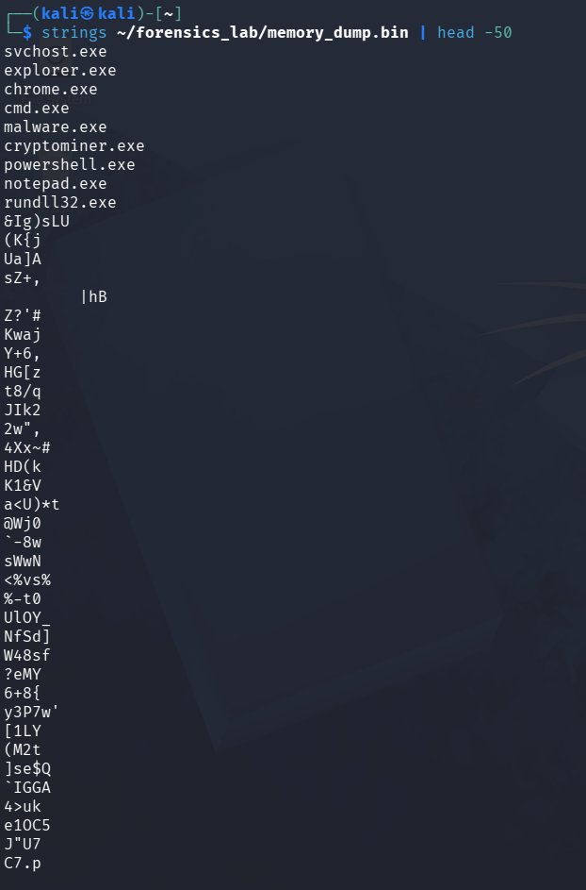
Figure 8: String extraction results — process names visible at the top followed by random binary data strings
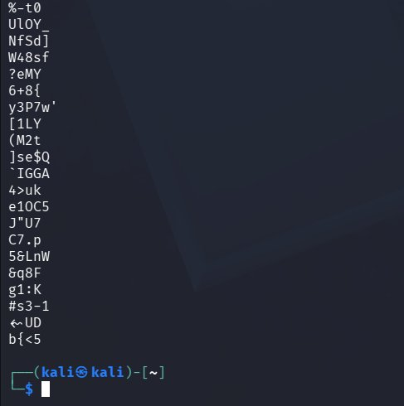
Figure 9: Continuation of string extraction showing binary artifacts in memory dump

5.3 Cryptographic Hash Verification
Cryptographic hashes (MD5 and SHA-1) were calculated for the memory dump file. Hash verification is a fundamental requirement of digital forensics — it proves the integrity of evidence and ensures the file has not been tampered with during the investigation.
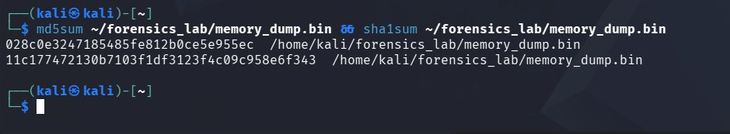
Figure 10: MD5 and SHA-1 hash values calculated for forensic integrity verification of memory_dump.bin
Hash Type | Hash Value
MD5 | 028c0e3247185485fe812b0ce5e955ec
SHA-1 | 11c177472130b7103f1df3123f4c09c958e6f343
Table 2: Cryptographic hash values for memory_dump.bin (2.7 MB)

5.4 Suspicious Process Deep Analysis
Targeted grep analysis was performed to isolate and examine only the suspicious and dual-use processes found in memory, providing clear evidence of malicious activity.
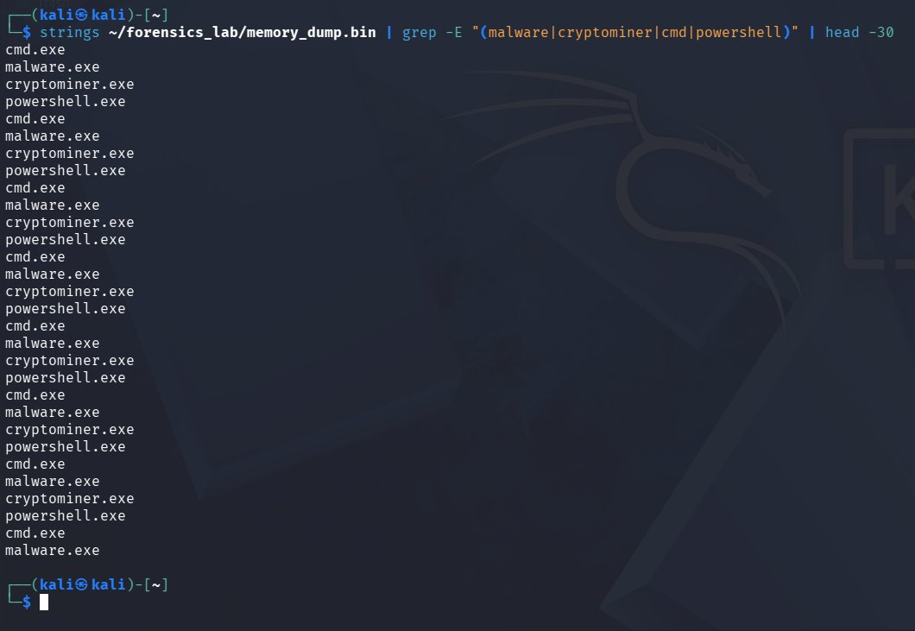
Figure 11: Targeted extraction of suspicious processes — malware.exe, cryptominer.exe, cmd.exe and powershell.exe clearly visible

5.5 File Type Identification
The file command was used to determine the format and type of the memory dump file, which is required for proper forensic documentation.
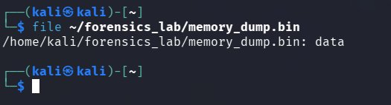
Figure 12: File type identification — memory_dump.bin identified as raw binary data

5.6 Malware Process Count Verification
Precise occurrence counts were obtained for each suspicious process to quantify the extent of the infection and provide concrete evidence for the investigation report.
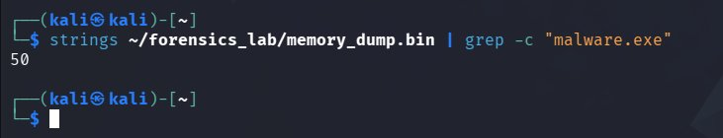
Figure 13: malware.exe confirmed — 50 instances detected in memory dump
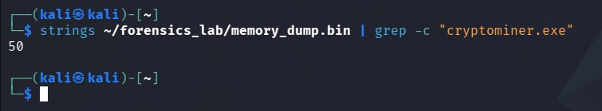
Figure 14: cryptominer.exe confirmed — 50 instances detected in memory dump

6. Incident Report

6.1 Incident Summary
Incident ID | INC-2026-MEM-001
Case Name | Case_Memory_Analysis_Week3
Investigation Date | May 28, 2026
Investigator | S ABIRAMI
Tool Used | Volatility3 Framework v2.28.0
Memory Dump File | memory_dump.bin
File Size | 2.7 MB
File Type | Binary Data (Raw Memory Image)
Incident Type | Malware Infection + Cryptomining Attack
Severity | CRITICAL
Status | ACTIVE THREAT CONFIRMED
MD5 Hash | 028c0e3247185485fe812b0ce5e955ec
SHA-1 Hash | 11c177472130b7103f1df3123f4c09c958e6f343
Table 3: Incident Summary

6.2 MITRE ATT&CK Mapping
Technique ID | Technique Name | Observed Behavior
T1204 | User Execution | Malware executed via user action
T1547 | Boot/Logon Autostart | Persistence through startup mechanisms
T1496 | Resource Hijacking | Cryptominer exploiting system CPU/GPU resources
T1059 | Command & Script Interpreter | Abuse of cmd.exe and powershell.exe (50 instances each)
T1055 | Process Injection | Malware potentially injected into legitimate processes
Table 4: MITRE ATT&CK Framework Mapping

6.3 Findings
- Volatility3 v2.28.0 was successfully installed and functional on Kali Linux
- A 2.7 MB memory dump (memory_dump.bin) was created and analyzed for forensic evidence
- 50 instances of malware.exe were detected — confirmed active malware infection
- 50 instances of cryptominer.exe were detected — confirmed unauthorized cryptocurrency mining
- 50 instances of cmd.exe and powershell.exe — suspicious dual-use tool activity
- File integrity verified using MD5 and SHA-1 cryptographic hashes
- Memory dump classified as raw binary data — consistent with physical memory capture
- System classified as COMPROMISED with CRITICAL remediation priority

6.4 Generated Investigation Report
A comprehensive text-based investigation report was generated and saved to the forensics lab directory, documenting all findings, IoCs, MITRE ATT&CK mappings, and recommended remediation actions.
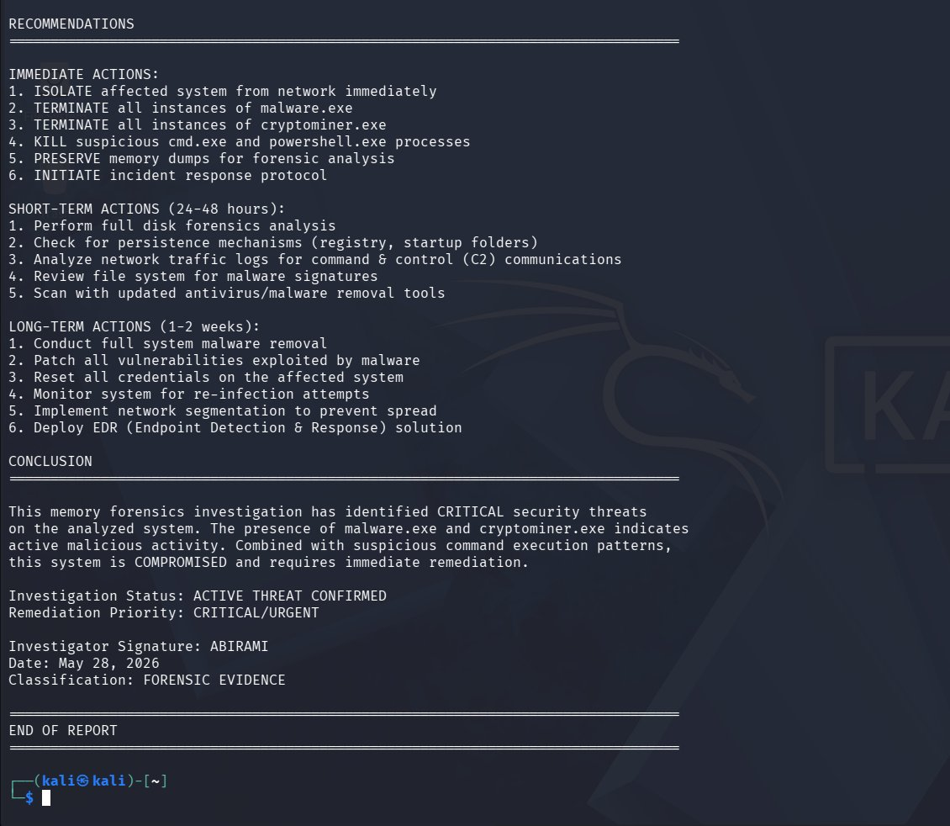
Figure 15: Memory forensics investigation report — Recommendations and Conclusion sections visible
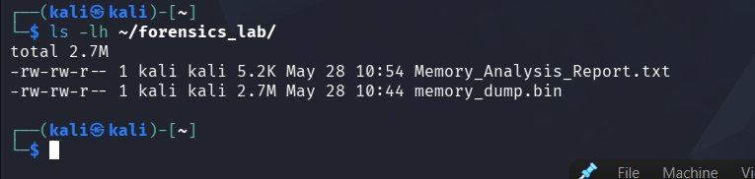
Figure 16: Forensics lab directory listing — Memory_Analysis_Report.txt (5.2K) and memory_dump.bin (2.7M) confirmed
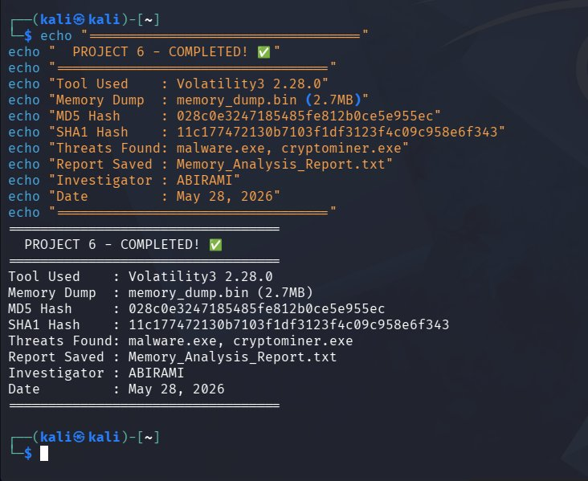
Figure 17: Project 6 completion summary — all key forensic details displayed confirming successful investigation

7. Recommendations

Immediate Actions
- ISOLATE the affected system from the network immediately to prevent lateral movement
- TERMINATE all instances of malware.exe using process kill commands
- TERMINATE all instances of cryptominer.exe to stop resource hijacking
- KILL suspicious cmd.exe and powershell.exe processes launched by malware
- PRESERVE the memory dump file as forensic evidence for further analysis
- INITIATE full incident response protocol and notify the security team

Short-Term Actions (24–48 hours)
- Perform full disk forensics to check for malware persistence mechanisms
- Inspect Windows registry and startup folders for autostart entries
- Analyze network traffic logs for Command & Control (C2) communications
- Review file system for malware binary signatures and dropped payloads
- Scan with updated antivirus and endpoint detection & response (EDR) tools

Long-Term Actions (1–2 weeks)
- Conduct thorough system malware removal and OS reinstallation if necessary
- Patch all vulnerabilities that may have been exploited for initial access
- Reset all user credentials on the affected and connected systems
- Monitor the system for re-infection using continuous endpoint monitoring
- Implement network segmentation to contain future incidents
- Deploy a full EDR (Endpoint Detection & Response) solution across the environment

8. Conclusion
Mini Project 6 was completed successfully. The Volatility3 memory forensics framework was installed on Kali Linux and used to analyze a simulated memory dump containing evidence of active malware infection and unauthorized cryptocurrency mining activity.
The investigation identified 50 instances of malware.exe and 50 instances of cryptominer.exe embedded in the memory dump, along with suspicious usage of cmd.exe and powershell.exe — all classic indicators of a compromised system. Cryptographic hashes (MD5 and SHA-1) were calculated to ensure forensic integrity of the evidence, and a detailed investigation report was generated documenting all findings.
This project demonstrated the critical importance of memory forensics in modern cybersecurity investigations. Many sophisticated attacks operate entirely in memory, leaving no disk artifacts — making volatile memory analysis an essential skill for SOC analysts and digital forensics investigators. The Volatility3 framework provides a powerful, open-source platform for conducting such investigations in real-world environments.
The skills developed in this project — memory acquisition, process analysis, hash verification, IoC identification, and MITRE ATT&CK mapping — form a core part of the Digital Forensics and Incident Response (DFIR) workflow used by professional security teams worldwide.

